**Main Heading**

**Subheading**

This is a sample paragraph that provides information about the topic.barattota oromoo  
barata  
**oromoo**  
kutaa 12ffaa*Darban*

1. Caalaa
2. Boonaa
3. Seenaa

• Caalaa

• Boonaa

• Seenaa

[Click here to learn more](https://www.example.com/)   
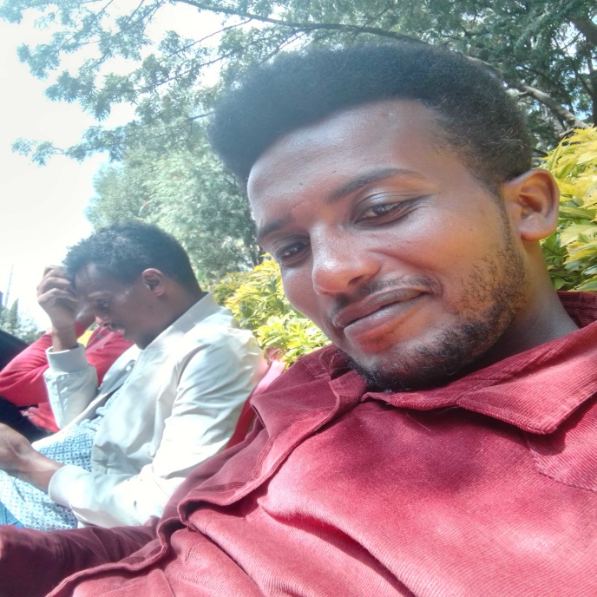  
[facebook](https://web.facebook.com/)  
[go to google](https://www.google.com/)  
[barsisa facebook](https://web.facebook.com/barsisa.hirko)